Scenario 1: Apply a 1% discount to loan interest rates for customers over 60.
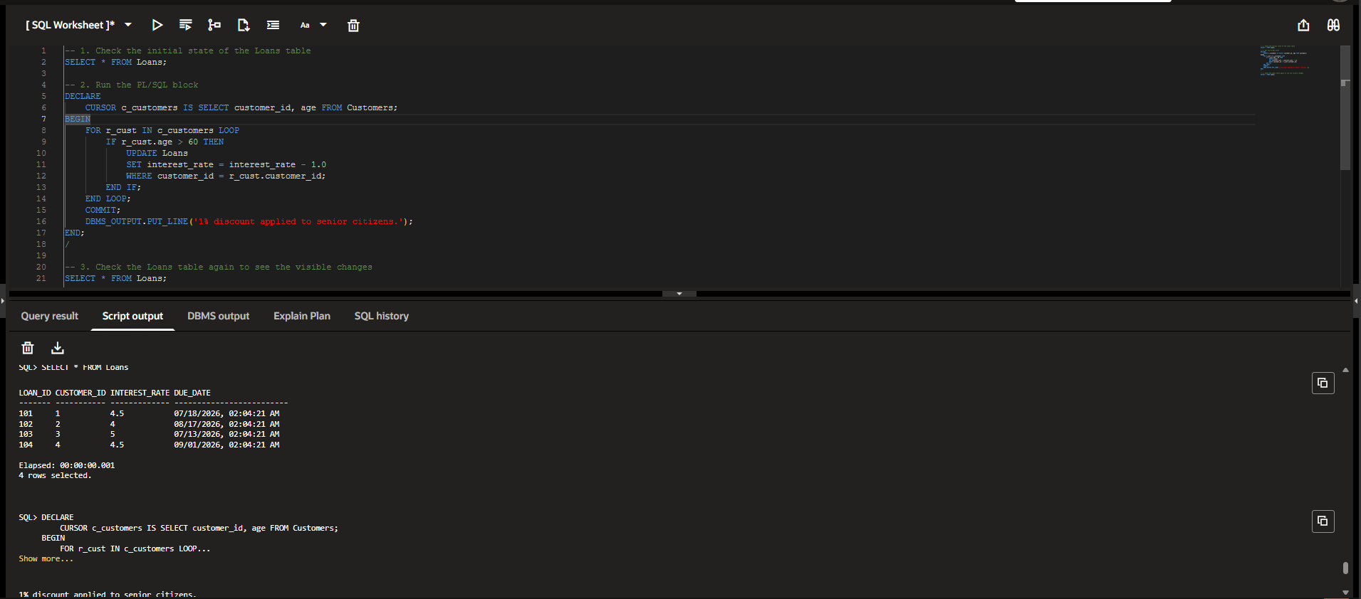
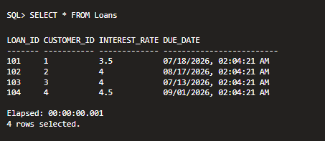
Code:
-- 1. Check the initial state of the Loans table
SELECT * FROM Loans;

-- 2. Run the PL/SQL block
DECLARE
CURSOR c_customers IS SELECT customer_id, age FROM Customers;
BEGIN
FOR r_cust IN c_customers LOOP
IF r_cust.age > 60 THEN
UPDATE Loans
SET interest_rate = interest_rate - 1.0
WHERE customer_id = r_cust.customer_id;
END IF;
END LOOP;
COMMIT;
DBMS_OUTPUT.PUT_LINE('1% discount applied to senior citizens.');
END;
/

-- 3. Check the Loans table again to see the visible changes
SELECT * FROM Loans;

Scenario 2: Promote customers to VIP status based on a balance over $10,000.
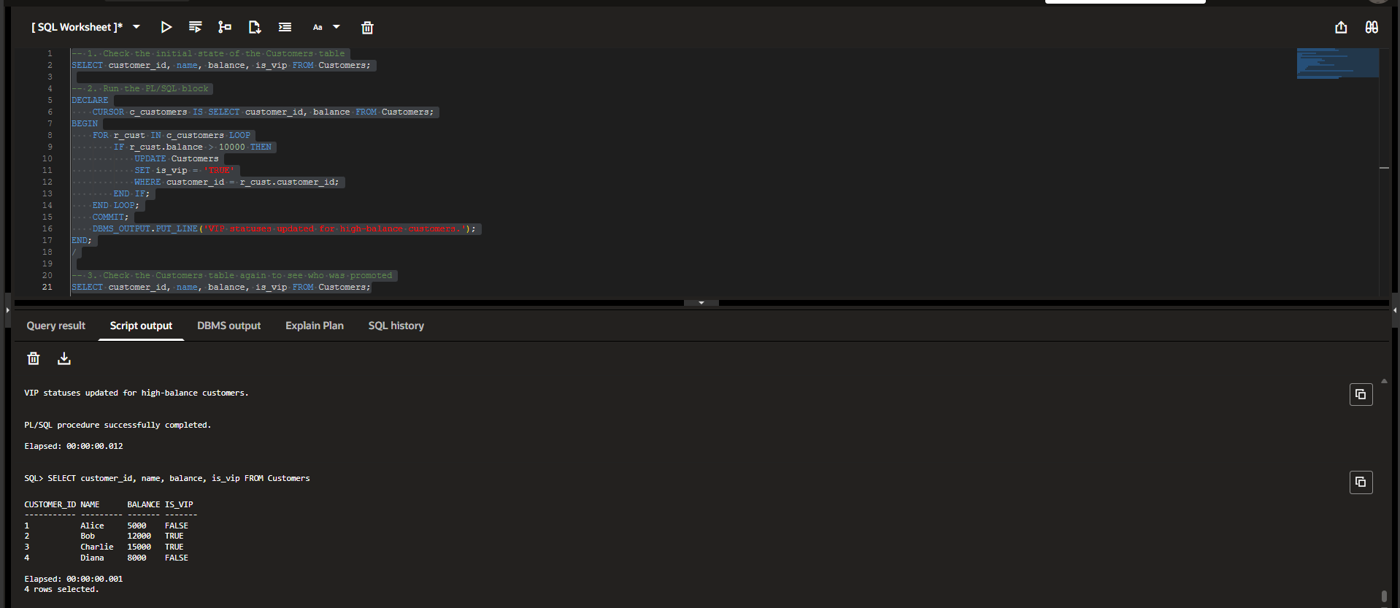
Code:
-- 1. Check the initial state of the Customers table
SELECT customer_id, name, balance, is_vip FROM Customers;

-- 2. Run the PL/SQL block
DECLARE
CURSOR c_customers IS SELECT customer_id, balance FROM Customers;
BEGIN
FOR r_cust IN c_customers LOOP
IF r_cust.balance > 10000 THEN
UPDATE Customers
SET is_vip = 'TRUE'
WHERE customer_id = r_cust.customer_id;
END IF;
END LOOP;
COMMIT;
DBMS_OUTPUT.PUT_LINE('VIP statuses updated for high-balance customers.');
END;
/

-- 3. Check the Customers table again to see who was promoted
SELECT customer_id, name, balance, is_vip FROM Customers;

Scenario 3: Send reminders to customers whose loans are due within 30 days.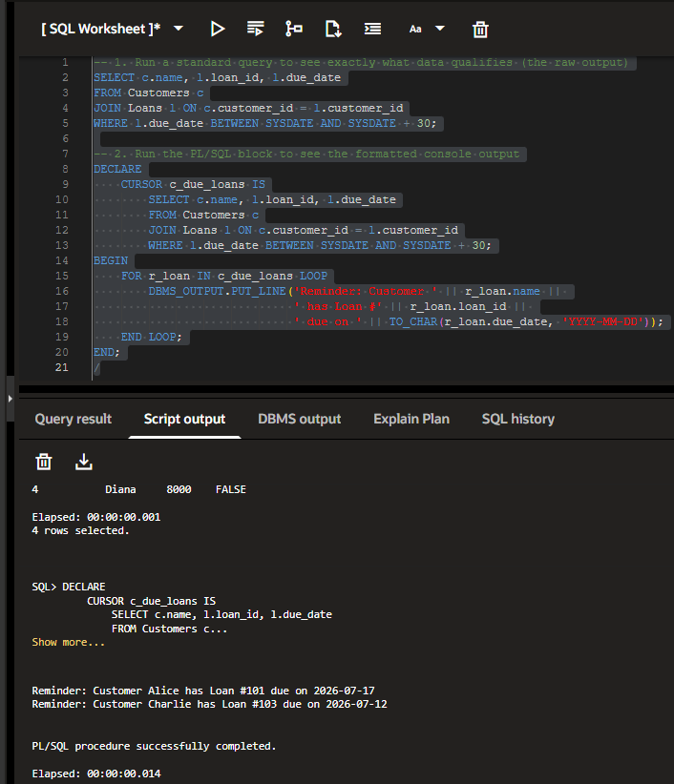
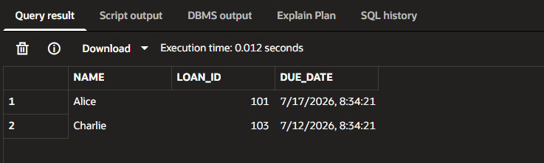
Code:
-- 1. Run a standard query to see exactly what data qualifies (the raw output)
SELECT c.name, l.loan_id, l.due_date
FROM Customers c
JOIN Loans l ON c.customer_id = l.customer_id
WHERE l.due_date BETWEEN SYSDATE AND SYSDATE + 30;

-- 2. Run the PL/SQL block to see the formatted console output
DECLARE
CURSOR c_due_loans IS
SELECT c.name, l.loan_id, l.due_date
FROM Customers c
JOIN Loans l ON c.customer_id = l.customer_id
WHERE l.due_date BETWEEN SYSDATE AND SYSDATE + 30;
BEGIN
FOR r_loan IN c_due_loans LOOP
DBMS_OUTPUT.PUT_LINE('Reminder: Customer ' || r_loan.name ||
' has Loan #' || r_loan.loan_id ||
' due on ' || TO_CHAR(r_loan.due_date, 'YYYY-MM-DD'));
END LOOP;
END;
/

